Total weight with packaging = 110 lbs

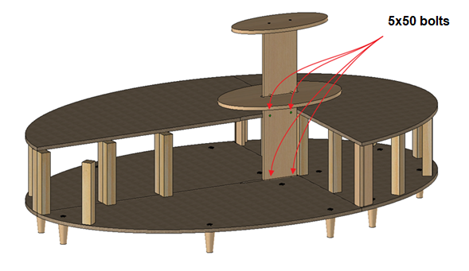

Each piece is connected at the red circles with the following hardware:

